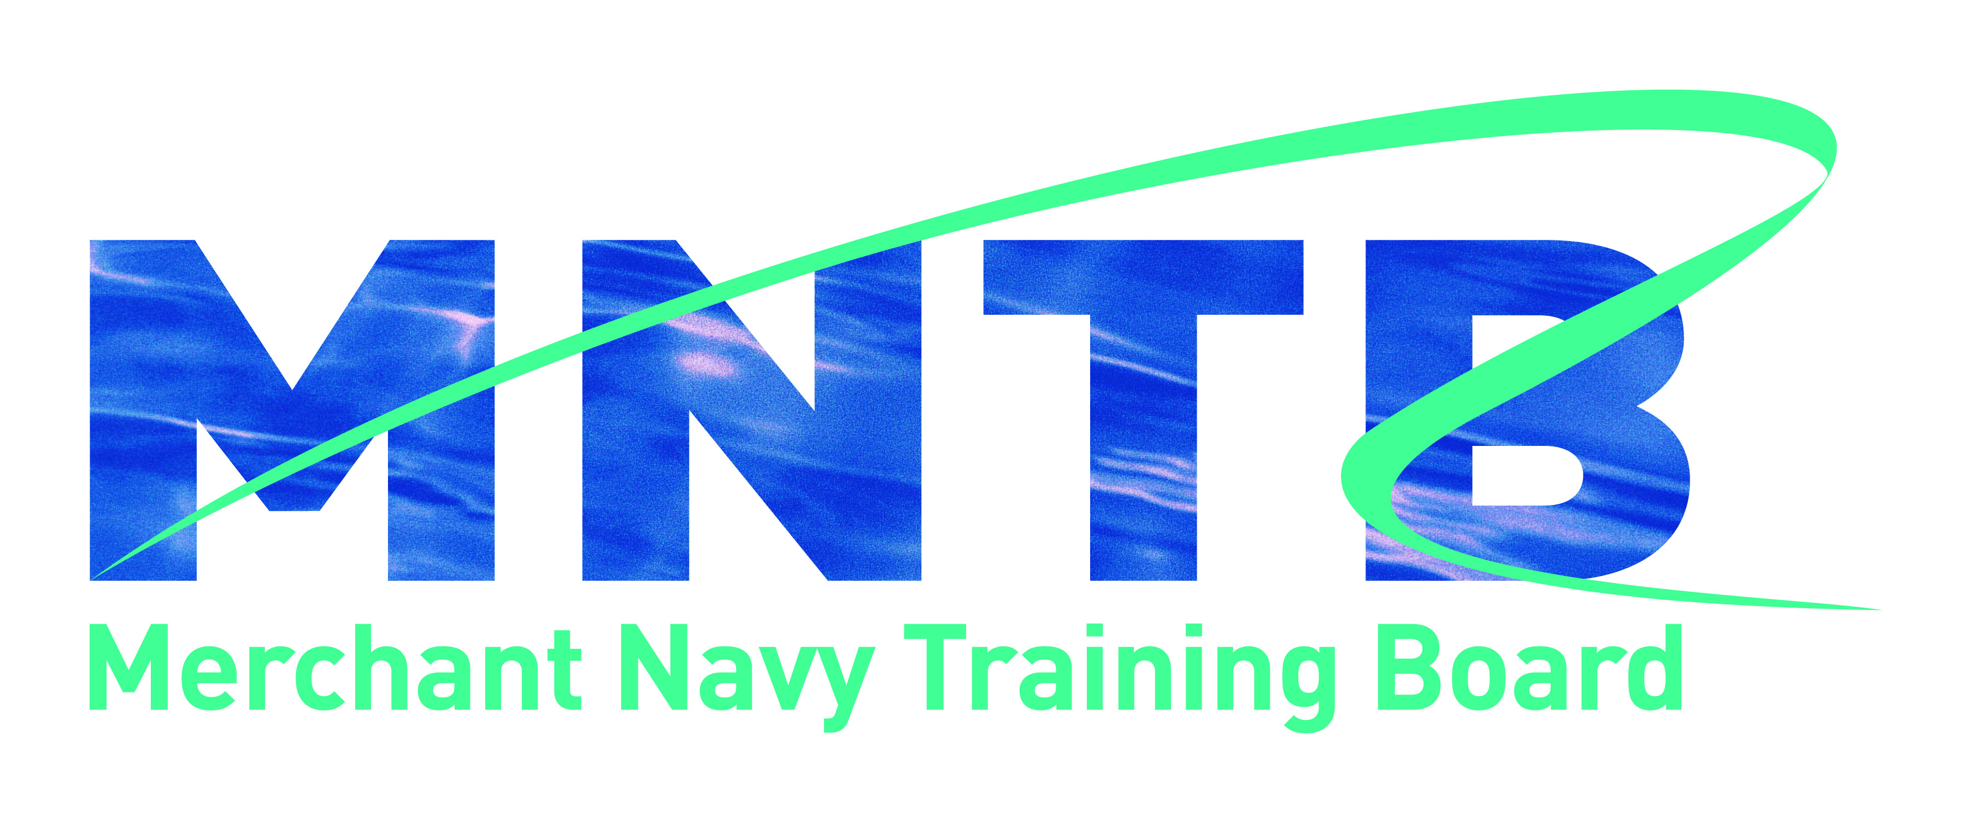

MNTB Good Practice Guidelines, Course Recognition Process
and Criteria

Introduction

The Merchant Navy Training Board (MNTB) will award recognition of maritime training courses that, in its judgement, meet criteria that have been established by its Board

This document sets out the MNTB criteria and process for course recognition. The criteria reflect good practice in training course provision and require courses to demonstrate that they meet an identified need, have been effectively constructed and demonstrate exemplary standards in delivery, management and quality assurance. These criteria must be met to the satisfaction of MNTB before recognition can be granted.

Companies providing training within the shipping industry may apply for MNTB recognition of their courses. The benefits of MNTB recognition to companies will be an increased profile and standing within the industry, an independent endorsement of its expertise, type and range of training provision, and acknowledgement that a course has met the good practice criteria set by the MNTB. It will also highlight a course as delivering effective training to meet a specified company/industry need.

Recognition will be evidenced through permission to use the ‘MNTB recognised course’ logo on company literature and webpages and inclusion on the MNTB website of recognised training courses.

MNTB recognition is not associated with, nor does it impact on, existing international and national quality assurance systems and processes – such as those identified by ISO, classification societies, insurance bodies, education and recognised industry bodies.

MNTB good practice guidelines

Training courses that receive MNTB recognition have demonstrated that the specified training course and training company/organisation meet its good practice guidelines, as set out below and as determined by the MNTB.

- The specified training course:

1.1 meets a defined industry or company need;

1.2 specifies the aims, objectives and learning outcomes to be achieved and delivers them successfully;

1.3 defines any entry requirements for course participants;

1.4 provides a suitably structured programme of learning, using a range of learning styles, appropriate learning materials and appropriate equipment;

1.5 is delivered using appropriate delivery methods and within appropriate timescales, having cognisance of suitable training day timescales – i.e a training day must not be in excess of ten hours, including relevant breaks, and must not include more than eight contact hours;

1.6 is appropriately linked and/or mapped to at least one of the following:

- international/national standards as defined by a creditable body (e.g. ISO);
- identifiable industry standards (e.g. STCW);
- national occupational standards;
- defined training frameworks;
- industry course criteria (e.g. IMO Model courses, MNTB short course criteria);

1.7 where relevant, provides appropriate assessment processes, tools and moderation;

1.8 is delivered by competent trainers with defined industry and training expertise and assessed by competent assessors with likewise expertise where relevant.

2. The training company/organisation has:

2.1 a sound financial basis on which it can offer the course and ensure its completion for those attending;

2.2 relevant professional/industry body membership and/or national accreditation/ auditing undertaken by a responsible body – e.g. ISO, a P&I association, a Classification Society, a flag state administration, EU recognition (through EMSA), or a government inspection body;

2.3 sufficient and appropriate human, physical, equipment and material resources, to the standards expected by the MNTB, to provide the training course(s) for which it is seeking MNTB recognition;

2.4 a recognised quality management system/quality standard covering training course provision where not covered by 2.2, above;

2.5 appropriate processes to ensure that those enrolling on its training courses meet stated entry requirements;

2.6 where relevant, suitable processes that provide appropriate, recognised and valid certification for successful course participants within its identified area of expertise;

2.7 appropriate publication/information about its training courses, including, as a minimum, their availability (venue, dates, timings as relevant), length of course, content, structure, trainers/lecturers, assessment, certification and course costs;

2.8 a suitable system to maintain relevant records of courses delivered, attendees and assessment outcomes;

2.9 a defined complaints process which is provided to all course participants prior to course attendance;

2.10 monitoring and reviewing processes in place to ensure the training course is up-to-date and continues to meet industry/company needs, along with self-evaluation of its provision and processes to ensure continuous improvement can be and is undertaken;

2.11 processes in place to inform the MNTB of relevant changes to any of the above points.

MNTB course recognition – submission process and costs

Request for course recognition will be made to the MNTB, using the submission form provided. Each submission must be made electronically, providing all supporting documentation as identified within the criteria. Once the submission has been received by the MNTB, an invoice for the non-refundable registration fee of £250 (plus VAT as applicable) will be sent. NB – this fee will be waived for UK Chamber of Shipping member companies.

Registration will enable the submission to be logged and an initial evaluation made as to the validity and suitability of the provision for progression to full evaluation. At this stage the submission may be rejected where it is evident that suitable information has not been provided for it to progress to full evaluation, in which case a report detailing why it has been rejected will be provided. NB – this will be where it is clear that various criteria have not been met or would not stand up to relevant scrutiny, rather than a minor issue such as missing/incomplete evidence and/or documentation.

Where a submission is recognised as suitable to continue to full evaluation, the applicant will be notified and invoiced for 50% of the evaluation fee plus travel and subsistence costs for the site/course visit, which is a required part of the evaluation process. Full evaluation for recognition will only proceed on receipt of the invoiced fees. The remaining 50% fee will be invoiced following the site visit and recognition can only be granted following payment of all fees.

It is understood that courses developed to meet a specific industry need may be adapted to provide bespoke solutions for individual companies. It is also possible for a submission to be made for multiple different courses, where certain organisational information and processes would be the same, i.e. with regard to Criteria 7, 11, 14, 15 and 16. In either of these instances where such submissions are to be made, the company should contact the MNTB beforehand to confirm the process, proforma details and costs. Companies wishing to have more than five courses recognised may wish to consider centre recognition, which may be of greater value and suitability in both commercial and cost benefit.

Costs

1. Registration fee - £250 (plus VAT as applicable) (no charge to UK Chamber of Shipping members)
2. Recognition service evaluation - £1,500 (plus VAT as applicable), plus agreed costs for site visit
3. On-going fee of £15.00 per participant per day (i.e. 3 day course £45.00 per participant)

Second and subsequent courses are charged as follows: above registration fee; recognition service evaluation - £1,000 (plus VAT as applicable) plus agreed costs for site visit; above on-going fee.

Course recognition decision

The MNTB will make its decision as follows:

i) Full recognition and agreement to use the MNTB name and logo on the relevant course/related publicity materials for a period of no more than 3 years;

ii) Conditional recognition, whereby confirmation of some issue/clarification/further information is required. Full recognition will be dependent on a satisfactory response;

iii) Refusal of recognition, where the MNTB believes that specific criteria are not met. The submitting provider will be given details of the perceived shortcomings. Such a course may be resubmitted at a later date where new evidence to support the criteria is provided. This will take the form of a new submission, along with the above associated costs.

Ongoing recognition

During the period of recognition the company is required to inform the MNTB of all minor and major changes/amendments to the course that would affect any of the recognition criteria, as identified in Criterion 16 of the application form. Where the changes/amends meet specified criteria in their own right then this will not affect recognition. However, should the changes/amends mean that any criterion would not be met then a suitable course of action will be identified in order to retain recognition. Where this is not agreed and/or actioned, recognition will be withdrawn, the course will be removed from the MNTB website list, and the MNTB name and logo must be removed from all course information/materials etc.

An interim review will be undertaken after 18 months, which will require information about and confirmation of any changes that have been implemented during the period of recognition.

MNTB course recognition is not connected in any way with international or national regulatory certification and cannot be used to claim certification of any type from any organisation/body.

All documentation and materials will be completely confidential to the MNTB and its appointed evaluators.

MNTB course recognition criteria

Criterion 1 – Meeting industry/employer needs
This criterion requires evidence of industry and/or company need for the training course.

Criterion 2 – Training course aims, objectives and learning outcomes
This criterion requires details of the aims, objectives and learning outcomes for the course.

Criterion 3 – Training course entry requirements
This criterion requires evidence of the academic/ occupational/other entry requirements for course participants and your processes for ensuring participants meet them. NB – some courses will not have entry requirements, which is perfectly acceptable depending on the type and nature of the course.

Criterion 4 – Training course structure and timescales
This criterion requires detail of the structure of the course, including the timescales over which it is planned, a breakdown of session timings, and the ratio of trainers to participants.

Criterion 5 – Training course delivery methods and learning styles
This criterion requires detail of the course delivery methods and learning styles that your course is designed to cater for.

Criterion 6 – Internationally/nationally recognised standards, frameworks, criteria
This criterion requires evidence of the internationally/nationally recognised industry or occupational standards, training frameworks and/or course criteria that your course links to.

Criterion 7 – Professional/industry body membership/accreditation
This criterion requires evidence of any professional/industry body membership/accreditation that the company/organisation has and any relevant detail of how it relates to the training course.

Criterion 8 – Assessment processes and tools
This criterion requires detail of the processes used to assess achievement of the course, where specific standards need to be achieved. It must include copies of the assessment tools that will be utilised and their appropriateness for the purpose.

Criterion 9 – Management and administration of the course and course resource requirements
This criterion requires detail of how the course will be managed, administered, and those involved, along with the resources that will be used to deliver the training course. It must include physical and equipment resources and copies of all material resources used in the course.

Criterion 10 – Trainer and assessor competence
This criterion requires detail of the trainers that will deliver the training course and any assessors involved in assessment. Evidence is required of their qualifications, industry and training/assessor expertise. Include copies of qualification certificates and references covering specific expertise, as utilised in the course, where identified in academic/ consultant/ trainer/ assessor profiles. NB – it is required that trainers will have teacher/lecturer/train the trainer/coaching expertise.

Criterion 11 – Quality assurance
This criterion requires evidence of the recognised, or suitable equivalent internal, quality assurance system(s) in place within the company/organisation that relate to this training course. Include detail of course monitoring and reviewing, self-evaluation and continuous professional development processes that are in place to ensure the training course is current, up-to-date and continues to meet industry/company needs.

Criterion 12 – Certification
This criterion requires detail of any certification and its validity that will be provided to those achieving the course outcomes.

Criterion 13 – Training course publicity/information provision
This criterion requires details and examples of any publicity/information available about the training course.

Criterion 14 – Records
This criterion requires evidence of the course record-keeping processes, including details of secure storage and how you are meeting data protection requirements, along with the type of information recorded, its purpose and any links to your quality procedures.

Criterion 15 – Complaints process
This criterion requires detail of the complaints process and how this is communicated to course participants.

Criterion 16 – Course revisions/changes
This criterion requires detail of the process to inform the MNTB of major course revisions and minor changes to any of the above criteria.

To make a submission, please use the MNTB Course Recognition Submission Form, which provides full information on the above criterion and the evidence that will be required to meet each criterion.

About the MNTB
The MNTB is the UK shipping industry’s central body for developing and promoting sector specific education, training and skills. Its role in setting training frameworks for new entrant officer and rating trainees and course criteria for STCW regulatory requirements places it in a unique position to oversee the training of future generations of high quality British seafarers, who are respected worldwide for their professionalism and skills.
The MNTB is a voluntary body and a part of the UK Chamber of Shipping, the trade association for the UK shipping industry. The work of the MNTB is overseen by a Board made up of representatives of shipping companies, seafarer unions, maritime education and training, and the Maritime and Coastguard Agency (MCA). The Department for Transport and the Maritime Skills Alliance are also represented on the Board.
A key role of the MNTB is to bring together these industry partners to agree the system and processes for new entrant seafarer education and training to meet regulatory and industry needs for a well qualified and certificated workforce. It also encompasses the availability and quality of updating and ongoing training for those serving at sea and for those moving ashore into ship management and related activities.

