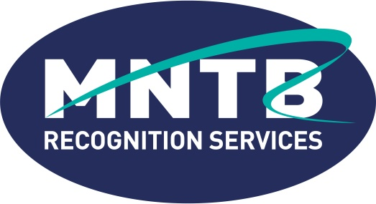
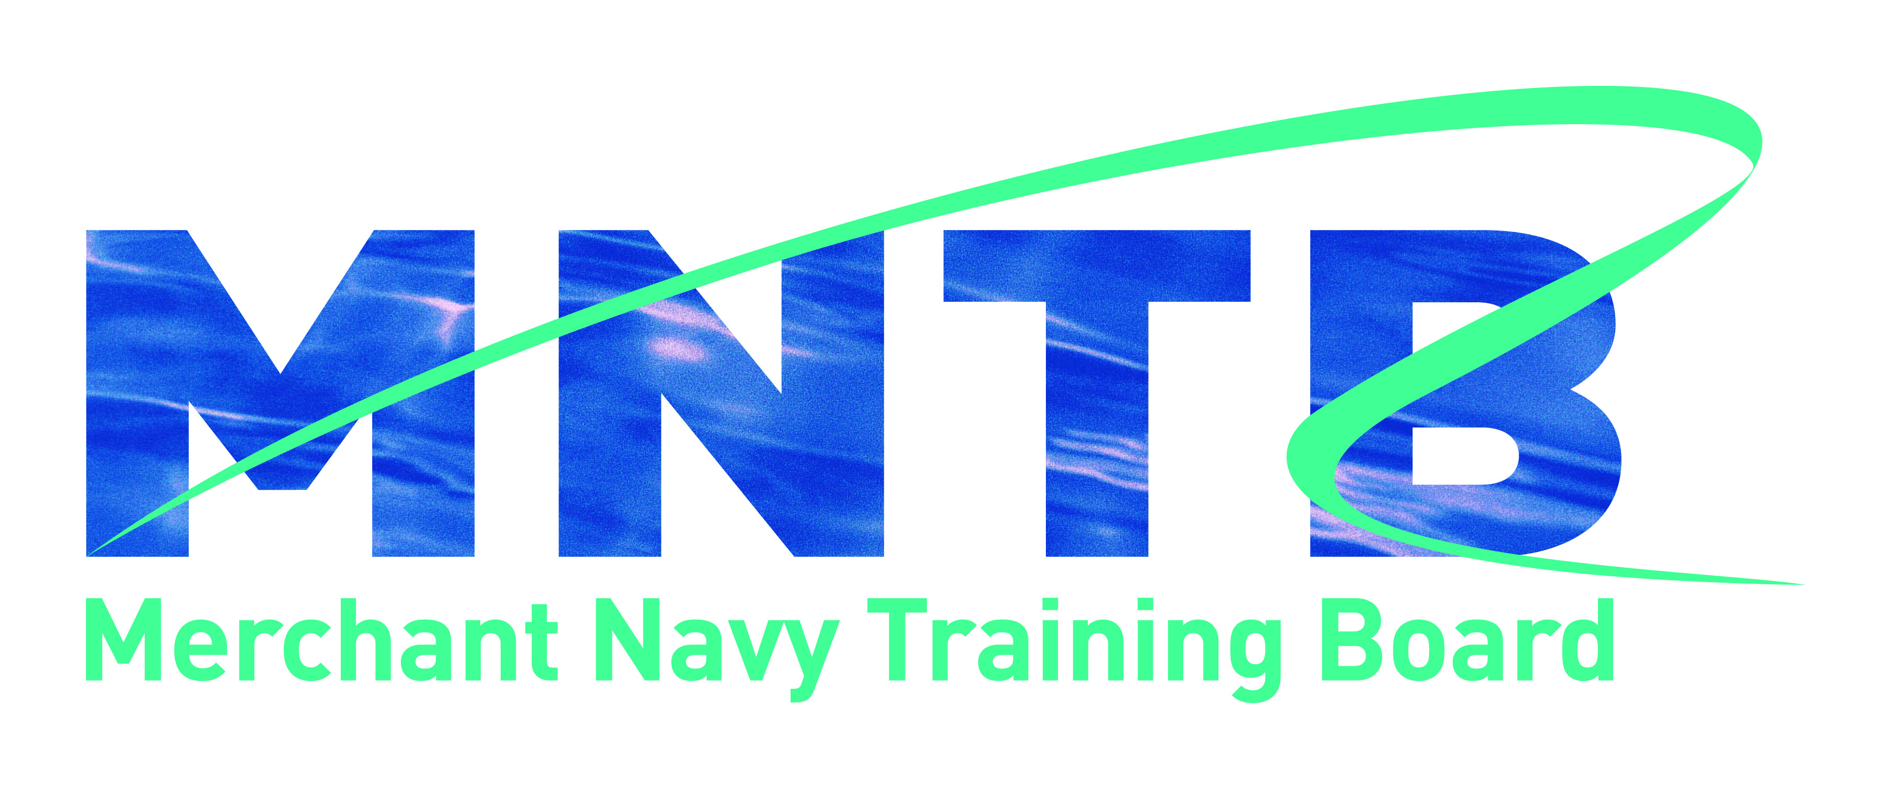

MNTB Recognition Services Contact form

Please complete the appropriate sections of this form and email to enquiry@mntb.org.uk

For office use only
Reference Number | MNTBRS/Course/000000?  MNTBRS/Centre/999999?
UK Chamber of Shipping Membership | Y / N

Name
Title
Organisation
Contact Email
Contact Telephone
Contact Address
Website
Recognition Type (tick as appropriate) | Course  Centre
Name of Course/s (if applicable)

Data Declaration

I understand that personal data collected on this form will be used for MNTB Recognition Services administration purposes only, and will be retained as a computer record by MNTB. All documentation and materials will be completely confidential to the MNTB and its appointed evaluators.

