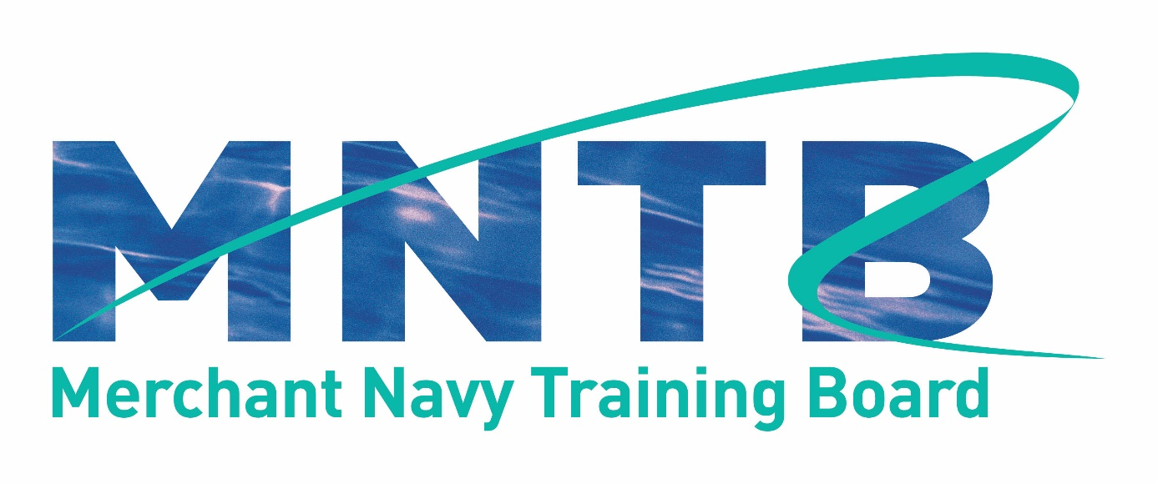

MNTB Good Practice Guidelines, Centre Recognition Process
and Criteria

Introduction

The Merchant Navy Training Board (MNTB) will award recognition of maritime training centres that, in its judgement, meet criteria that have been established by its Board

This document sets out the MNTB criteria and process for centre recognition. The criteria reflect good practice in training provision and require centres to demonstrate that they are serving identified industry needs; have effective management systems, appropriate premises and resources (physical and human) to effectively deliver the courses offered; and that the courses have been effectively constructed and demonstrate exemplary standards in delivery, management and quality assurance. These criteria must be met to the satisfaction of MNTB before recognition can be granted.

Companies providing training within the maritime industry may apply for MNTB recognition of their training centre. The benefits of MNTB recognition to companies will be an increased profile and standing within the industry, an independent endorsement of its expertise, type and range of training provision, and acknowledgement that a centre has met the good practice criteria set by the MNTB. It will also highlight the centre as providing effective training to meet identified industry needs.

Recognition will be evidenced through permission to use the ‘MNTB recognised centre’ logo on company literature and webpages and inclusion on the MNTB website of recognised training centres.

MNTB recognition is not associated with, nor does it impact on, existing international and national quality assurance systems and processes – such as those identified by ISO, classification societies, insurance bodies, education and recognised industry bodies.

MNTB good practice guidelines

Training centres that receive MNTB recognition have demonstrated that the specified training centre and its course provision meet its good practice guidelines, as set out below and as determined by the MNTB.

1. The training centre

1.1 is meeting industry needs through the range of courses it offers and its client base, repeat and new business;

1.2 is owned, managed and operated by a reputable company/organisation which has a sound business model to ensure, as far as is possible, continuous and ongoing provision in line with the company vision and mission/aims and objectives;

1.3 has appropriate premises, facilities, equipment, and staff resources to deliver the range of training courses offered;

1.4 has a quality management system that covers all aspects of training provision, including premises, physical and staff resources, training delivery and associated assessment and course certification, plus specific continuous improvement measures;

1.5 provides accurate, relevant and up-to-date information about the centre and its provision through an appropriate range of media.

2. Training provision is provided by courses which:

2.1 specify the aims, objectives and learning outcomes to be achieved and delivers them successfully;

2.2 define the entry requirements for course participants;

2.3 provide a suitably structured programme of learning, using a range of learning styles, appropriate learning materials and appropriate equipment;

2.4 are delivered using appropriate delivery methods and within appropriate timescales, having cognisance of suitable training day timescales – i.e a training day must not be in excess of ten hours, including relevant breaks, and must not include more than eight contact hours;

2.5 are appropriately linked and/or mapped to at least one of the following:

- international/national standards as defined by a creditable body (e.g. ISO);
- identifiable industry standards
- national occupational standards;
- defined training frameworks;
- industry course criteria (e.g. IMO Model courses, MNTB short course criteria);

2.6 where relevant, provide appropriate assessment processes, tools and moderation;

2.7 are delivered by competent trainers with defined industry and training expertise and assessed by competent assessors with likewise expertise where relevant

MNTB centre recognition – submission process and costs

Request for centre recognition will be made to the MNTB, using the submission form provided. The submission must be made electronically, providing all supporting documentation as identified within the criteria. Once the submission has been received by the MNTB, an invoice for the non-refundable registration fee of £250 (plus VAT as applicable) will be sent. NB – this fee will be waived for UK Chamber of Shipping member companies.

Registration will enable the submission to be logged and an initial evaluation made regarding the validity and suitability of the centre for progression to full assessment. At this stage the submission may be rejected where it is evident that suitable information has not been provided for it to progress to full evaluation, in which case a report detailing why it has been rejected will be provided. NB – this will identify clearly where various criteria have not been met or would not stand up to relevant scrutiny, rather than a minor issue such as missing/incomplete evidence and/or documentation.

Where a submission is recognised as suitable to continue to full evaluation, the applicant will be notified and invoiced for the evaluation fee plus travel and subsistence costs for the site visit, which is a required part of the evaluation process. Full evaluation for recognition will only proceed on receipt of the invoiced fees. The site visit and recognition can only be granted following payment of all fees.

UK Costs

1. Registration fee - £250 + VAT as applicable (no charge to UK Chamber of Shipping members)

2. Recognition service evaluation - Large Centre (offering 21 courses or more):
£10,000 + VAT as applicable, plus agreed costs for site visit
Annual renewal fee of £3,000 +VAT as applicable

3. Recognition service evaluation - Small Centre (offering less than 21 courses):
£7,500 + VAT as applicable, plus agreed costs for site visit
Annual renewal fee of £2,000 +VAT as applicable

Overseas Costs

1. Registration fee - £250 + VAT as applicable (no charge to UK Chamber of Shipping members)

2. Recognition service evaluation - Large Centre (offering 21 courses or more):
£15,000 + VAT as applicable, plus agreed costs for site visit
Annual renewal fee of £4,500 +VAT as applicable

3. Recognition service evaluation - Small Centre (offering less than 21 courses):
£10,750 + VAT as applicable, plus agreed costs for site visit
Annual renewal fee of £3,000 +VAT as applicable

Centre recognition decision

The MNTB will make its decision as follows:

i) Full recognition and agreement to use the MNTB name and logo on the relevant course/related publicity materials for a period of no more than 3 years;

ii) Conditional recognition, whereby confirmation of some issue/clarification/further information is required. Full recognition will be dependent on a satisfactory response;

iii) Refusal of recognition, where the MNTB believes that specific criteria are not met. The submitting provider will be given details of the perceived shortcomings. Resubmission may be made at a later date where new evidence to support the criteria is provided. This will take the form of a new submission, along with the above associated costs.

Ongoing recognition

During the period of recognition the company is required to inform the MNTB of all minor and major changes/amendments to the centre and any specific courses that would affect any of the recognition criteria, as identified in Criterion 10 of the application form. Where the changes/amends meet specified criteria in their own right then this will not affect recognition. However, should the changes/amends mean that any criterion would not be met then a suitable course of action will be identified in order to retain recognition. Where this is not agreed and/or actioned, recognition will be withdrawn, the centre will be removed from the MNTB website list, and the MNTB name and logo must be removed from all centre and course information/materials etc.

An interim review will be undertaken after 6 months, which will require information about and confirmation of any changes that have been implemented during the period of recognition.

MNTB centre recognition is not connected in any way with international or national regulatory certification and cannot be used to claim certification of any type from any organisation/body.

All documentation and materials will be completely confidential to the MNTB and its appointed evaluators.

MNTB centre recognition criteria

Criterion 1 – Meeting industry needs
This criterion requires evidence of industry needs through the range of courses offered by the centre, its client base, repeat and new business.

Criterion 2 – Reputable company/organisation and sound ongoing business model
This criterion requires evidence and detail of the company’s reputation and business model, including vision and mission/aims and objectives and strategic plan.

Criterion 3 – Appropriate premises, facilities, equipment and staff resources
This criterion requires detail about the premises, facilities, equipment and staff resources to deliver the range of courses offered.

Criterion 4 – Quality management system
This criterion requires evidence of the quality management system in place to cover all aspects of training provision.

Criterion 5 – Centre and training provision information
This criterion requires evidence of the information provided by, and about, the centre and its training provision and the range of web/internet based and printed media and materials used for that purpose.

Criterion 6 – Internationally/nationally recognised standards, frameworks, criteria
This criterion requires evidence of the internationally/nationally recognised industry or occupational standards, training frameworks and/or criteria that the courses meet and/or link to.

Criterion 7 – Training delivery methods and learning styles
This criterion requires evidence that training delivery methods and learning styles are relevant to the courses they are designed to cater for and the range of learning styles exhibited by learners.

Criterion 8 – Assessment processes and tools
This criterion requires detail of the processes used to assess achievement of specific courses, where identified standards need to be achieved. It must include copies of assessment tools that will be utilised and their appropriateness for the specific course and purpose.

Criterion 9 – Certification
This criterion requires evidence that certification provided for specific courses have appropriate relevance and validity according to individual course requirements and achievement/completion.

Criterion 10 – Centre changes/course revisions
This criterion requires detail of the process to inform the MNTB of specific changes to the centre ownership, management, and course provision, including course revisions and minor changes to any of the above criteria.

To make a submission, please use the MNTB Centre Recognition Submission Form, which provides full information on the above criterion and the evidence that will be required to meet each one of them.

About the MNTB
The MNTB is the UK shipping industry’s central body for developing and promoting sector specific education, training and skills. Its role in setting training frameworks for new entrant officer and rating trainees and course criteria for STCW regulatory requirements places it in a unique position to oversee the training of future generations of high quality British seafarers, who are respected worldwide for their professionalism and skills.
The MNTB is a voluntary body and a part of the UK Chamber of Shipping, the trade association for the UK shipping industry. The work of the MNTB is overseen by a Board made up of representatives of shipping companies, seafarer unions, maritime education and training, and the Maritime and Coastguard Agency (MCA). The Department for Transport and the Maritime Skills Alliance are also represented on the Board.
A key role of the MNTB is to bring together these industry partners to agree the system and processes for new entrant seafarer education and training to meet regulatory and industry needs for a well qualified and certificated workforce. It also encompasses the availability and quality of updating and ongoing training for those serving at sea and for those moving ashore into ship management and related activities.

