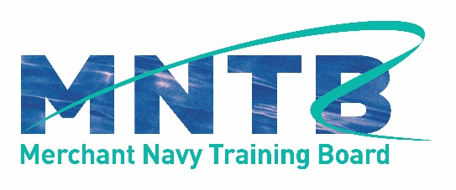

MNTB Job Listing Instructions for Companies

April 2020

Thank you for contacting the MNTB about listing a job opportunity on their website.
Please provide the following information along with a copy of your company logo and send to the following email addresses:

lauren.bishopp@mntb.org.uk
rachel.gurnett@mntb.org.uk

If any information is not provided, the MNTB will not post the opportunity on the website

Company Name:
Position Available: [include rank where necessary]
Location:
Position Type: [permanent/temporary etc]
Start Date:
Date Posted: [MNTB will complete]
Expires:
Website: [please provide direct link to application page, if no website, provide an email contact]

